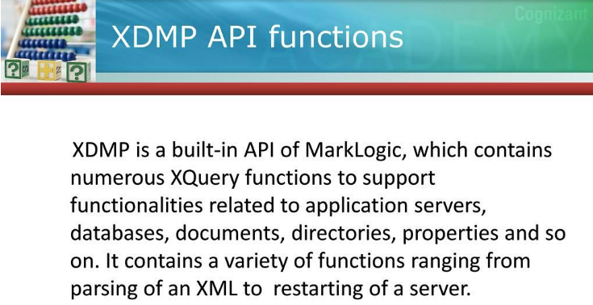

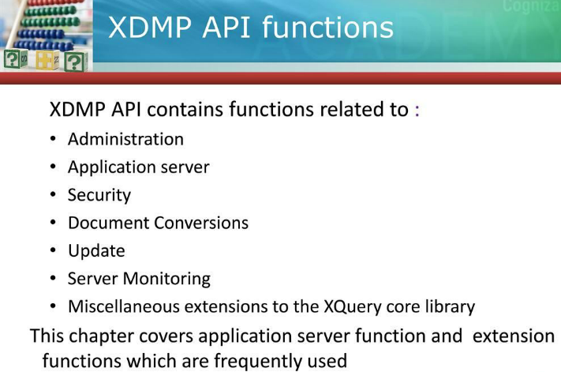

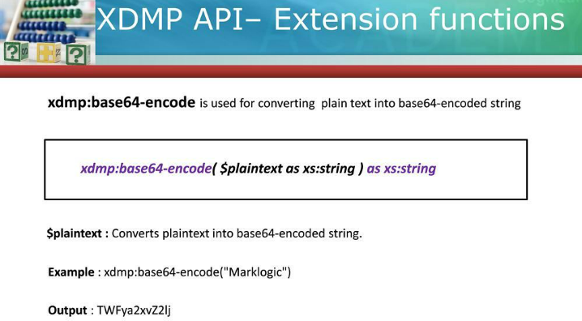

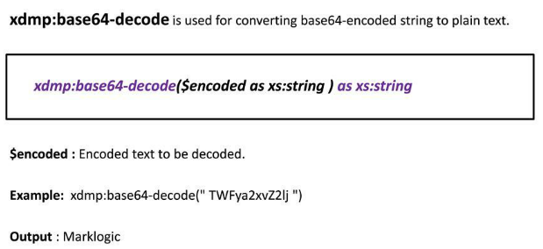

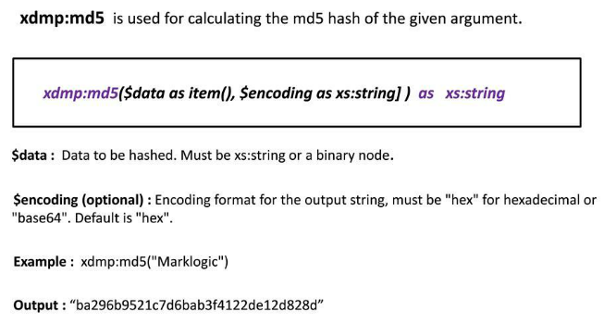

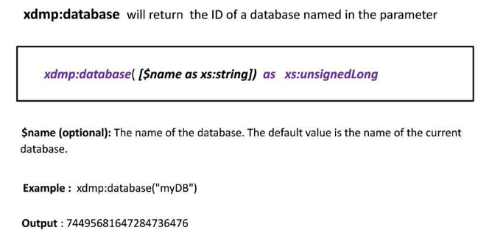

**Example: xdmp:database()**

* **Returns** 1050493710840072517 //Id of default database where you are executing your query

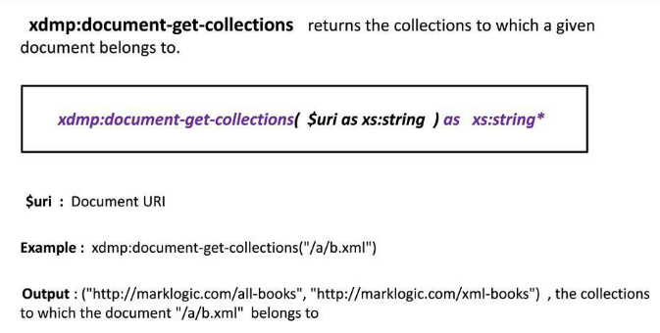

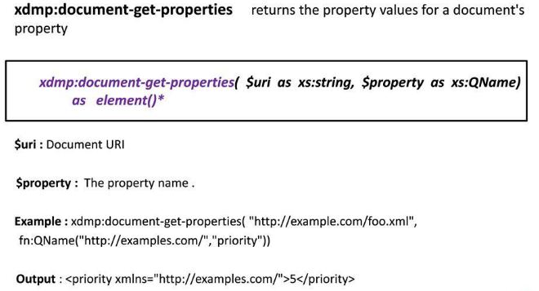

**Example:** xdmp:document-get-properties("/books.xml",xs:QName("prop:last-modified"))

**Output>** <prop:last-modified xmlns:prop="http://marklogic.com/xdmp/property">2013-05-20T15:45:01+05:30</prop:last-modified>

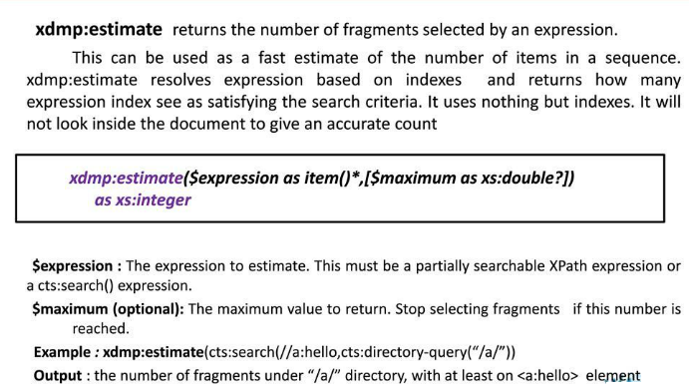

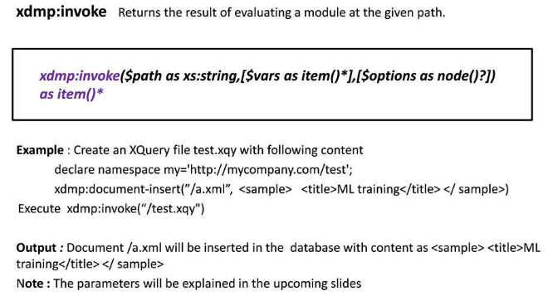

**Example:**

**//Create an xquery file “authHelper.xqy”.**

declare variable $userName as xs:string * external;

declare variable $password as xs:string * external;

xdmp:login($userName,$password)

**--Passing external values**

xdmp:invoke((xs:QName("admin"),10,xs:QName("passw0rd"),50))

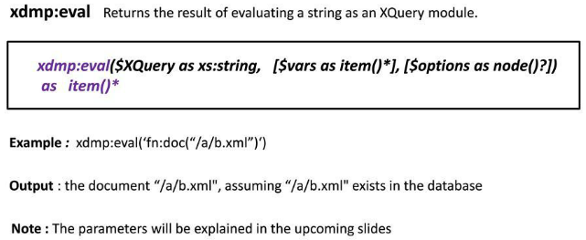

**Example:**

**let $queryAsString :=** "declare variable $a as xs:integer external;

declare variable $b as xs:integer external;

($a+$b)

"

**return** xdmp:eval($queryAsString,(xs:QName("a"),10,xs:QName("b"),50))

**Output>> 60**

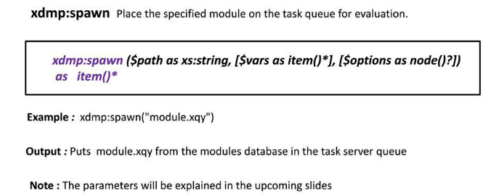

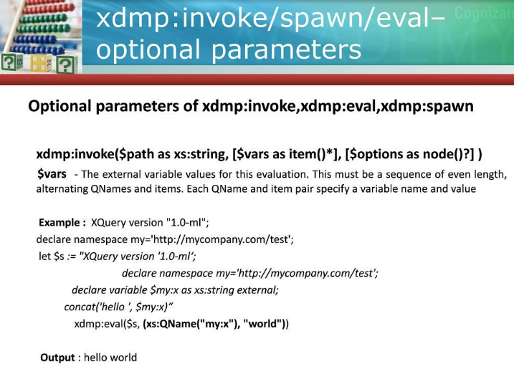

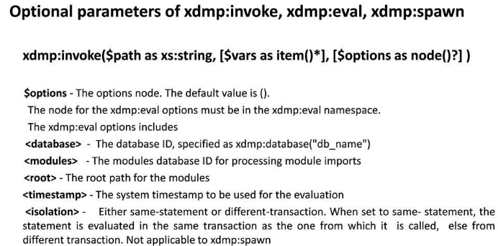

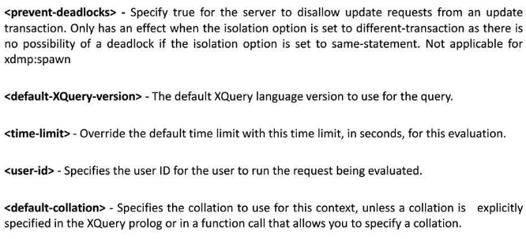

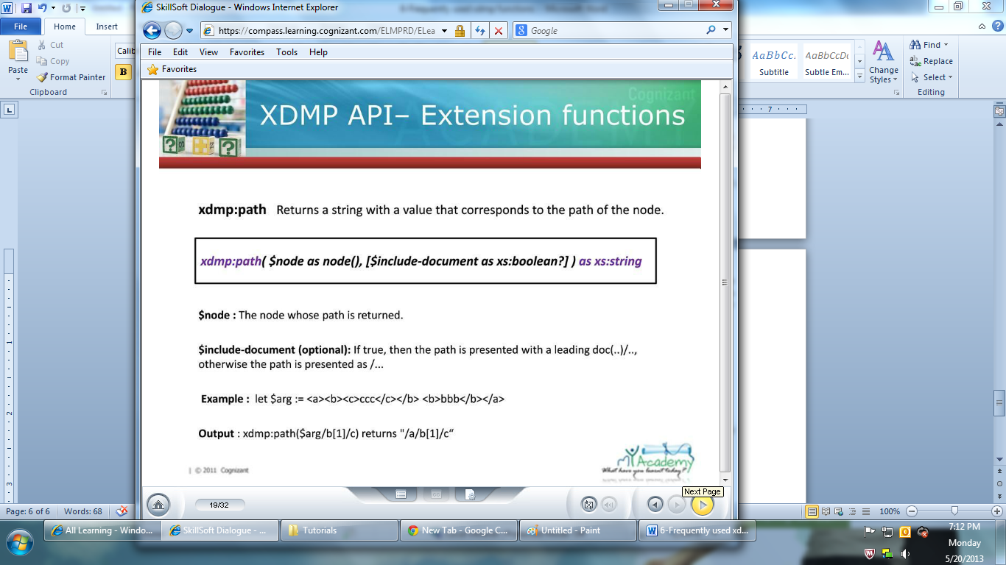

**Example:**

xdmp:path(fn:doc("/books.xml")/books/book)

**Output>**

/books/book[1]

/books/book[2]

/books/book[3]

/books/book[4]

/books/book[5]

/books/book[6]

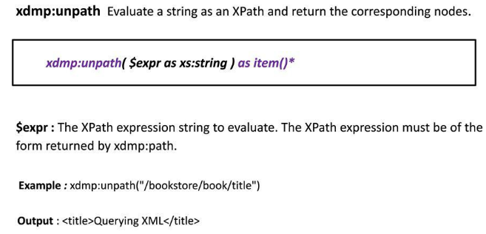

**Example:**

Xdmp:unpath(/books/book[1] )

Xdmp:unpath(/books/book[2] )

Xdmp:unpath(/books/book[3] )

Xdmp:unpath(/books/book[4])

Xdmp:unpath(/books/book[5] )

Xdmp:unpath(/books/book[6])

**Output>**

<book id="0">xml<authorname auid="101">Holmen</authorname><price>100rs</price></book>

<book id="1">xpath</book>

<book id="2">xquery</book>

<book id="3">core java</book>

<book id="4">j2ee</book>

<book id="5">struts 2.x</book>

**Logging:**

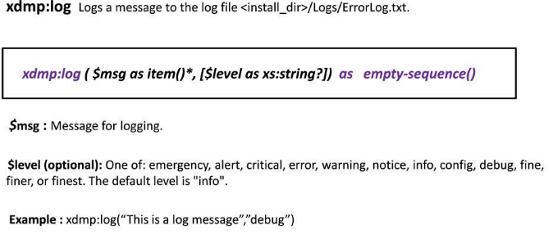

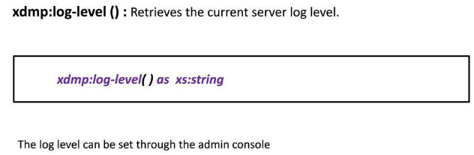

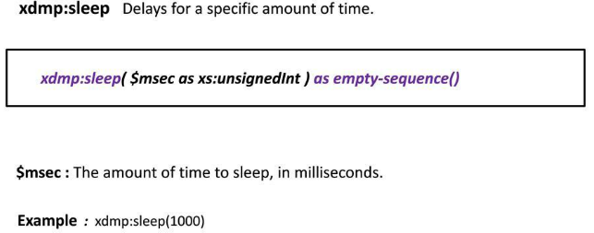

**Query Profiling:**

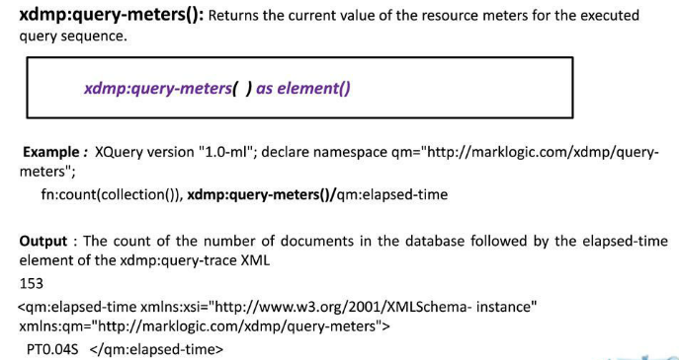

**Serialization:**

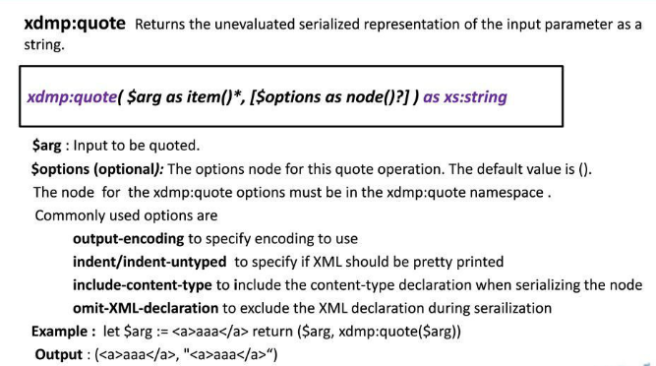

**De-Serialization:**



